

Voluntary Sector Development Fund

Guidance Notes 2025-26

Deadline for applications:
5.00pm, 5 September 2025

We cannot consider late applications

What is the VSDF for?

The Voluntary Sector Development Fund (VSDF) contributes to the costs associated with meeting the required registration qualification criteria set by the Scottish Social Services Council (SSSC) to help employers in achieving a qualified, trusted, skilled, confident and valued workforce. Funding is made available subject to Ministerial decision taking into account Scottish Government priorities.

Who can apply?

The increasing demand for qualified employees, particularly through the registration requirements of the SSSC, puts considerable pressure on employers to increase investment in the provision of qualifications, the VSDF is designed to support this investment. The following can apply.

Voluntary organisations who are a registered charity and are registered with the Care Inspectorate.

Voluntary organisations that employ staff who are required to be registered with the SSSC.

Small and medium sized organisations in the voluntary sector are particularly encouraged to apply.

Eligibility criteria

SSSC registration categories eligible for funding this year are:
Part | Level | Service type
Social care worker | Support worker | Care at home service
Social care worker | Support worker | Housing support service
Social care worker | Support worker | Care home service for adults
Social care worker | Practitioner | Care at home service
Social care worker | Practitioner | Housing support service
Social care worker | Practitioner | Care home service for adults
Social care worker | Supervisor (practice qualification only) | Care at home service
Social care worker | Supervisor (practice qualification only) | Housing support service
Social care worker | Supervisor (practice qualification only) | Care Home Service for Adults

who need to achieve one of the following qualifications:

- SVQ Social Services and Healthcare at SCQF level 6, or
- SVQ Social Services and Healthcare at SCQF level 7.

For 2025-2026, the SSSC and Scottish Government would encourage level 7 applications to support supervisors who have had an extension to their qualification condition and still have to gain their practice qualification.

The sole purpose of VSDF funding is to ensure that eligible staff are able to gain a qualification required to meet SSSC registration. If an organisation’s employees are SSSC registered without any conditions attached, they are not eligible for VSDF funding.

Find out more about these Register parts on our website:
https://www.sssc.uk.com/registration/help-with-register-parts-fees-and-qualifications/

The application process

The application form is very straightforward. It asks details of:

- how many staff across the organisation are qualified to meet SSSC registration requirements

- how many staff across the organisation are in the process of undertaking qualifications to meet SSSC registration requirements

- how many staff have yet to start qualifications that meet SSSC registration requirements.

It asks for the individual’s SSSC registration number. Where they are not registered yet, you should provide the staff member’s National Insurance number. You must also provide the registration category of the staff member and the qualification they are seeking to achieve.

Applying organisations must send supporting documents with their application; these are of critical importance and must include a recent annual report and accounts and a detailed training plan.

The information from applications will inform our understanding of the development and upskilling of the workforce.

Applying organisations will receive an acknowledgement email from a member of the SSSC VSDF team confirming receipt of the application. If you do not receive this within 10 working days, please contact us to ensure we have received your application. The automated reply email is not confirmation of receipt.

How long is the grant for?

Qualifications must be completed within 24 months of 1 January 2026. Payment will be made before 31 March 2026. The SSSC expects that staff will have completed at least 75% of the qualification by the 24-month stage. You must tell the SSSC about any significant delay for any staff member starting or completing their qualification as soon as possible.

Please refer to Appendix 1 for key dates.

What are the main terms of the grant?

Funding is secured on an individual basis and must be used for the stated member of staff and for the qualification identified in the application. It is only transferable to another member of staff with prior agreement from the SSSC. Please complete Appendix 2 to notify us of any changes.

As a condition of the grant, organisations must ensure that the members of staff apply to register with the SSSC within three months of acceptance of the grant.

- VSDF funding cannot be used to support employees undertaking a modern apprenticeship route.

- Any sessional/bank/relief workers must be directly employed by the applying organisation and not through an agency.

- VSDF funding cannot be used for progression of employees, eg, if they hold an SVQ at SCQF level 6 they cannot apply for an SVQ at SCQF level 7. The exception to this is supervisors with a qualification condition extension in place.

- VSDF funding does not support the management role. Employees cannot be in a management role before starting, or while undergoing their qualification.

- Grant holders will be required to provide the SSSC with an interim report at 12 months and a final report at 24 months evidencing each individual’s achievement of the agreed qualifications.

If at any time an organisation realises it will not use the grant award in the timescales set out in the grant award letter it must inform the SSSC and repay the unspent funds.

Who will decide which applications are successful?

A panel consisting of representatives from the SSSC, the Coalition of Care and Support Providers Scotland (CCPS) and Scottish Government oversee the application process and approve successful applications. The panel will make decisions on funding amounts. The SSSC will manage and disburse the VSDF on behalf of the panel.

Organisations must demonstrate how the funding will help them to meet these requirements through achieving the relevant qualifications. Outcomes will be measured on the numbers qualified and the resulting readiness to meet standards.

The maximum funding awarded to any one voluntary organisation will be £24,000, with a £1,200 limit per staff member. However, if the total requested funding (from all organisations) exceeds the available grant, the awarded amounts will be proportionally reduced.

Factors which will influence allocation of funds include:

- number of applications – if total funding applied for exceeds the total grant available, a reduction will be applied

- performance of organisation – reports from previous funding years will identify where an organisation has made best use of funds

- reports – where an organisation has failed to submit reports regarding funding received in previous years this may result in the panel rejecting the application.

Decisions regarding all applications will be made in a fair and equitable way.
It may not be possible to provide funding for all the individuals applied for. Other sources of funding may be used by employing organisations in combination with VSDF to maximise the number of people achieving qualifications.

Applications and awards will be decided in November 2025. Successful applicants will receive a grant award decision letter in December 2025. We will make payments in March 2026 upon receipt of a signed grant award letter and bank details from successful organisations.

Guidelines for completing your application

All fields are mandatory and must be completed.

Section 1 – Company details

- Provide organisation and contact details.

- Tick all types of services provided by your organisation.

- Enter Care Inspectorate Care Service (CS) numbers relating to the individuals you are applying for. NB. Not the organisation’s Service Provider (SP) number.

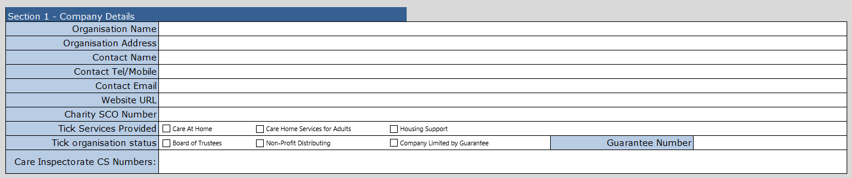

Section 2 – Employee qualifications

Provide a breakdown of qualifications held by employees relevant to the VSDF eligible funding categories (Care at home, housing support and care home service for adults).

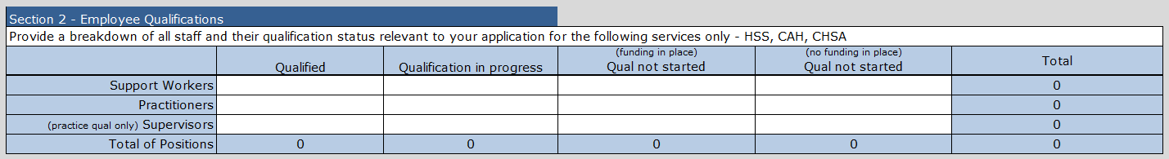

Section 3 – Impact of funding

Provide information about how this funding will impact on your organisation’s overall learning and development plan (training plan) if your application is successful.

Section 4 – Candidates applying for funding

- Provide details of the employees and qualification level required.

- Registration category and Qualifications Title columns have pre-filled drop-down boxes; select the cell and click the right-hand arrow to see options.

- The start date for training cannot be before 1 January 2026.

- Each line amount should not exceed £1,200, and the total amount of funding requested should not exceed £24,000.

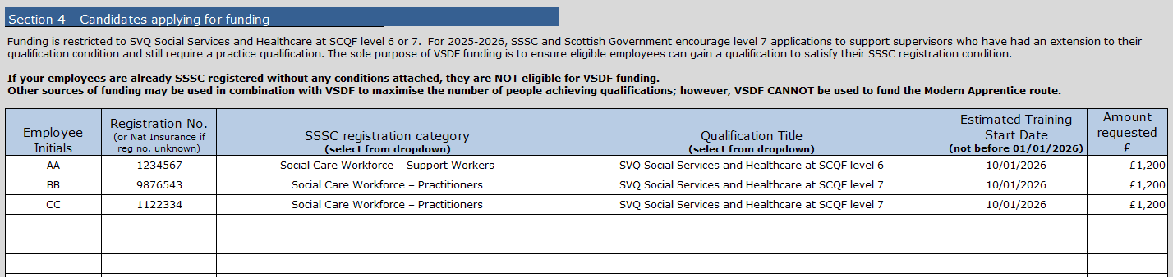

Final checks and submission

- Ensure you have checked the accuracy of information in the form.

- Ensure you include all the supporting documents along with your application to vsdf@sssc.uk.com

- An example subject line for the email would be ‘VSDF Application 2025-26 – Caring Company Ltd’.

- It is the organisation’s responsibility to ensure we have received their application. You can email vsdf@sssc.uk.com with any queries for clarification of the criteria or asking for help to complete the form.

Voluntary Sector Development Fund Grant 20YY-YY (please insert year)

I would like to request permission to transfer funding from the following candidates.

Employee initials | SSSC registration category | SSSC registration number | Qualification applied for | Amount requested | Reason for transfer

To the following candidates.

Employee initials | SSSC registration category | SSSC registration number | Qualification applied for | Qualification start date | Amount requested

Name of organisation:
Name of contact:
Position of contact:
Date:

