TECHNICAL/PROFESSIONAL APPRENTICESHIP AGREEMENT

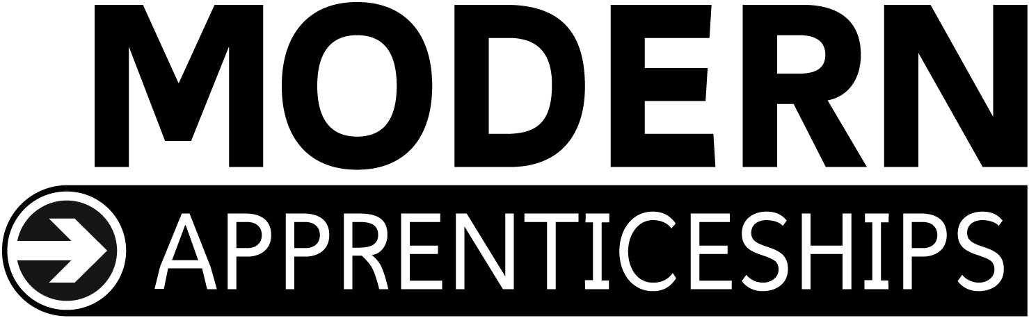

This Training Agreement is entered into by:

Name of Employer:
Name of Technical/ Professional Apprentice:
Name of Apprenticeship Centre:

All partners in the agreement will adhere to the SSSC Codes of Practice

The Employer’s responsibilities are to:

1 employ the apprentice subject to the employer’s usual terms and conditions of employment;

2 provide the apprentice with the facilities, training and work place opportunities necessary to achieve the selected Framework outcomes specified in the apprentice’s personal training plan;

3 pay the apprentice an agreed salary which meets National Minimum Wage criteria, reflects the obligations of the employer and the opportunities for the apprentice;

4 in the event of the employer becoming unable to retain the apprentice after completion of the apprenticeship, to use reasonable endeavours to secure employment elsewhere;

5 in the event of the apprenticeship being terminated prematurely by either the employer or apprentice for any reason other than dismissal for unsatisfactory performance or misconduct, to use reasonable endeavours to secure employment and continuation of this apprenticeship elsewhere;

6 operate a formal Health and Safety policy and undertake the necessary legal and contractual responsibilities for health and safety of the apprentice; and

7 operate an Equal Opportunities policy which meets all legal requirements.

The Technical/ Professional Apprentice’s responsibilities are to:

1 work for the employer in accordance with the agreed terms and conditions of employment;

2 undertake training, attend courses if required, keep records, and take assessments to be determined by the employer and/or Modern Apprenticeship Centre, and carry out such work as may be required in order to achieve the selected Framework outcomes specified in the apprentice’s personal training plan;

3 be diligent, punctual, behave in a responsible manner and in accordance with the requirements of Health and Safety legislation relating to the apprentice’s responsibilities as an individual; and

4 promote at all times the employer’s best interests.

The Modern Apprenticeship Centre’s responsibilities are to:

1 agree the content of the apprentice’s personal training plan as confirming that the selected Framework outcomes and training plans meet the criteria of this apprenticeship

2 contract with the employer to provide the training and assessment necessary to enable the apprentice to achieve the selected Framework outcomes specified in the apprentice’s personal training plan; and

3 use its best endeavours to ensure that the employer provides the apprentice with the facilities, training and work place opportunities necessary to achieve the selected Framework outcomes specified in the apprentice’s personal training plan.

This agreement to be signed by all parties:
Employer |  | Date:
Technical/ Professional Apprentice  (or Parent/Guardian, if under 18) |  | Date:
Modern Apprenticeship Centre |  | Date:

